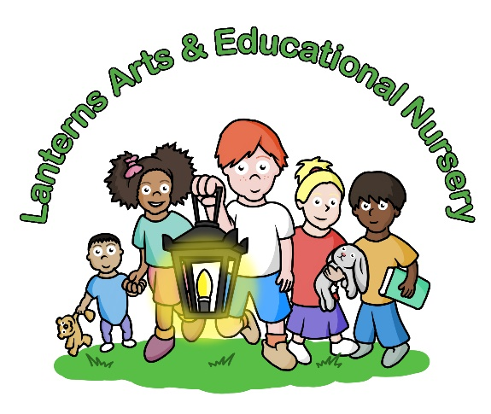

January / February 2025 Newsletter
Dear Parents,
Lanterns Arts & Educational Nursery would like to welcome everyone back after the Christmas and New Year holidays, and we hope everyone had a lovely break celebrating the festive season in the way you planned for, with the New Year 2025 beginning to get fully under way. With the weather being extremely cold at present please ensure your child is dressed warmly for the season with extra jumpers and clothing in their lockers. Please do not send your child into nursery in Disney costumes or any other dressing up clothes which are far to cold for this time of year. All children must have a winter coat for garden time with scarves, hats and gloves as the children do get extremely upset when they are too cold due to insufficient clothing provided. A change of footwear such as wellies are a good idea as the grass can become very wet and sandals are not appropriate in this weather.
The next planned event for Lanterns is our Baby school Tea Party for our Baby School parents only, which has had a change of date and is now being held in the Baby Room on Friday 31st January 2025 from 4pm-5pm. We do apologise for the change of date, but we still hope many of you will be able to attend as this event gives you an opportunity to meet other parents, make new friends, read your child’s profile folder and have the time to chat to your child’s key worker about any queries, updates or issues you may have. These individual class events do provide a supportive environment for staff, parents and babies to bond, also offering a sense of security and trust with parents being able to meet staff in a more relaxed environment, asking questions and building on our parent partnership which is quite different to the rushed drop off and pick up which does not allow parents time to discuss their child’s development, care and learning in a more individual and personal way.
We would just like the parents of Year 1 to take note that the Year 1 Junk Modelling Workshop will be taking place on Friday 7th February 2025 from 4pm-5pm for parents only. The theme for this workshop will be ‘Winter Wreaths’ to take home for your front door, kitchen or hanging anywhere to showcase you and your child’s masterpiece. Please be aware that there is sand, water, glue and paint in the gallery for this workshop in case you wear your work clothes/Sunday best, aprons will be provided.
We did have some changes of staff at the end of 2024 with some staff who had been with us for many years, and although sad to see people move on with their lives and do new things we do wish them all the best in their new adventures. Lanterns rarely has any changes of staff but since covid it is noticeable that people’s lives do seem to be changing dramatically with the pandemic highlighting people’s priorities, health and personal values and often wanting to focus more on family and changing jobs to work closer to home. We now have some lovely new staff in the nursery bringing fresh ideas, new approaches, new friendships and becoming totally involved in Lanterns life, our curriculum and events and we would like to welcome Ms Fatema in Year 1 and Ms Nyla in Year 2 to the Lanterns team.
The Lanterns school of Performing Arts as opened after the Christmas/New Year period and we would like to welcome all the new nursery children who are now enjoying ‘Baby Ballet’ on a Saturday morning at 10:45am -11:30am. If you would like your child to do a trial class, please do not hesitate to contact the office to book your child in just for one lesson. We also offer Baby Tap after the ballet class if you would like to do two classes or your child prefers tap. This school opens termly according to the educational school calendar.
We would like to welcome our new parents to Lanterns Arts & Educational Nursery and once again thank you for all your support and check out our Lanterns Arts Nursery Instagram page which is ‘lanternsartsnursery’ and do also take a look at our websites www.lanternsartsnursery.co.uk, www.lanternsschooloftheperformingarts.co.uk, www.lanternstudiotheatre.co.uk.

Janet Viola
Director/Manager


This Photo by Unknown Author is licensed under CC BY-NC

