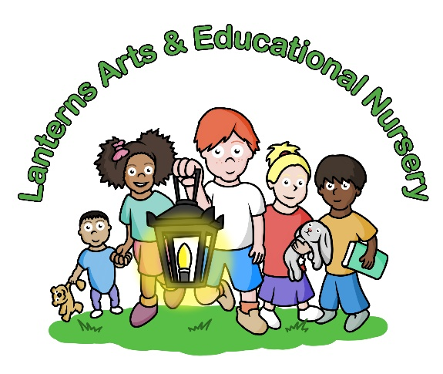

February / March 2025 Newsletter
Dear Parents,
The Lanterns Arts & Educational Nursery event calendar has had a great start to the New Year with our lovely Baby School Tea Party and our creative Year 1 Junk Modelling Workshop in our Gallery, and we do hope everyone who attended enjoyed themselves. We are sorry that you were unable, or should I say forbidden to take home your lovely winter wreaths but Ms Reba, Head of Year 1 would like to display the wreaths in the Year 1 classroom to begin with, and then you are more than welcome to take them home when we change displays. These workshops are a great way of meeting and making new friends, talking to staff, catching up with your child’s profile folders and enjoying these events with your child.
The next planned event on the calendar is the Year 2 Junk Modelling Workshop on Friday 28th February 2025 with the theme of making ‘Treasure Baskets’, and the Year 3 Junk Modelling will take place on Friday 7th March 2025 with the theme of decorating ‘Giant Easter Eggs’. We have taken note that Year 3 hasn’t had a junk modelling workshop before with parents which we are now including this on our events calendar. It is important that parents do comment and suggest and forward ideas to us and we are grateful to those parents who have informed us that they would like to see a Year 3 gallery workshop on the events calendar.
We will be taking part in World Book Day on Thursday 6th March 2025 so do start preparing for your child to come to nursery on this day dressed as their favourite book character which is always loved and a very successful day with the children and staff. Please do encourage your child to bring their favourite book from home which we will take great care of and can be read out to the whole class. Please ensure your book is clearly labelled with your child’s name and class.
The Duckling Project will be returning to Lanterns Arts & Educational Nursery on 1st April 2025 where we will be having duck eggs delivered in an incubator which will hopefully hatch and is always one of the most extremely loved projects of the school each year.
This project links to the classrooms medium-term planners covering the themes and topics such as life cycles, The Ugly Duckling story and spring animals. It is very important that when the children are learning all the necessary early years foundation stage themes of early education, that they have a hands-on and practical approach which embeds their learning with our projects, visits and outings throughout the year.
The Easter party will be taking place on Wednesday 9th April 2025 which is a ‘fancy dress party’ with the children making Easter Bonnets for our Easter hat parade. Parents are more than welcome to join in and make their own Easter hats for the event and this party will be from 3pm-4:45pm. Lanterns Nursery uses the Easter period to teach the children about Spring, plant growth, colours, sensory changes, new beginnings, kindness, stories and working together with lots of art projects in our gallery and having fun taking part in Easter egg hunts, games and discussing the importance of the traditional events on the U.K calendar. This also connects to our Duckling Project taking place in April and Farm Visit which we hope to take place in May 2025.
Unfortunately, the weather is still a little against us and as I am sure you are more than aware there is a lot of worrying news at present informing us that covid strains, flu and colds are very strong this year and rather dangerous which the scientists have no reason for but must be taken seriously. We do ask that children come dressed warmly to nursery, with the appropriate outdoor clothing at present. Please do take this seriously as hospitals are extremely busy with adults and children with dreadful chest infections and viruses which are very serious, and we are being very careful in the nursery to limit times in the garden where needed and in extreme cold weather. We are aware that parents do want their children to have fresh air and outside play time, but it is more important to keep the children warm, safe and avoid outdoor play for too long to try and avoid the children catching these serious illnesses as much as possible. The staff have been suffering from many viruses being brought into the school in the last few months which causes a lot of absence and many problems with staffing so if your child is ill, please do not bring them into nursery during their contagious period as it just infects everybody else. Please do call us to check for guidance if your child should come to nursery or ask about the school recommended period to be kept at home.
We would like to welcome our new parents to Lanterns Arts & Educational Nursery and once again thank you for all your support and check out our Lanterns Arts Nursery Instagram page which is ‘lanternsartsnursery’ and do also take a look at our websites www.lanternsartsnursery.co.uk, www.lanternsschooloftheperformingarts.co.uk, www.lanternstudiotheatre.co.uk.


Janet Viola
Director/Manager

This Photo by Unknown Author is licensed under CC BY-NC

