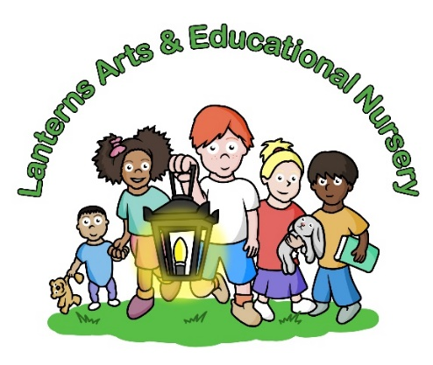

March / April 2025 Newsletter
Dear Parents,
We had hoped that we were about to welcome ‘Spring’ into our world and although we now have more ‘light’ in the mornings and evenings we are still being subjected to freezing temperatures which is rather depressing. Hopefully April will be warming up as we are heading towards British Summer Time with the clocks changing, and hopefully something will happen with the sun which has so far only blessed us with one weekend!
Since the beginning of the year, we have now had four extremely good parent partnership workshops with Year 1, 2 and 3 being held in the Gallery which was very successful and great fun for everyone involved. We are very grateful for so many parents attending these events and it is so good for the children creating models such as decorating Easter eggs, making treasure boxes and Winter wreaths. These masterpieces turned out to be very lovely especially seeing the joint effort between parents and children. What a lovely start to the year and thank you for all your support.
World Book Day took place on Thursday 6th March 2025 with all the children looking wonderful in their chosen Disney or story book character costumes which they loved wearing all day, sharing their favourites stories from home and having stories read to them throughout the day. We hope you liked all the photographs on our nursery Instagram @lanternsartsnursery and I have to say it’s lovely to have Charlene back after maternity leave to become the chief photographer again who tries to take as many photos as possible for everyone. There is the occasional absence where the Director has to become the chief apprentice who also does her best, but usually shouted out afterwards with the out of focus, badly structured and probably missing most of the crucial moments! One does ones best in a needed situation and I do like to ensure memories are captured for all parents attending these events.
We hope to be having our Duckling Project starting on Tuesday 1st April 2025 with approximately five duckling eggs being delivered in an incubator which we all hope will hatch. This has been an extremely loved project by the nursery for many years. This project links to all the classroom medium term planners which covers the themes and topics such as life cycles, and the stories of ‘That’s Not my Duck’ and ‘The Ugly Duckling’.
It is very important when the children are learning all the necessary Early Years Foundation Stage themes of early education and also to give them a hands on and practical experience which then embeds their learning for the future.
Of course, we are not always lucky for all the eggs to hatch but if this is the case it will be all hands-on deck to find the local farm to lend us a couple of eggs, so we do not disappoint the children. We all cross our fingers this project goes smoothly this year. Please be aware the ducks are not for sale or to be sold as pets or kept in your bathroom for dinner as the company will be collecting the ducklings 10 days later to live their lives on their farm.
The Easter party will be taking place on Wednesday 9th April 2025 which will be a fancy dress party, and parents are more than welcome to make their own Easter bonnets while the children will be making their bonnets at the nursery ready for our Easter Parade with our prizes for the best hats and then an Easter afternoon tea for everyone. We are sorry but we will be unable to accommodate any siblings over the age of 12 months to our Easter party including the afternoon tea. Please return your attendance slips as soon as possible to reception.
Lanterns is working on launching an update of our nursery website which we hope to go live shortly, and we plan is to include individual classroom updates and newsletters from each room on the parent zone. We used to send the classroom room newsletter to each parent by email which has become too time consuming, and easier for us if we now put them into the parent zone for everyone to have access to see what the children are working on each room.
We are very grateful for the local council after many, many years for recently putting speed bumps in Millharbour and double yellow lines around the nursery school entrance which was actually never requested but after all these years the council has obviously realised that we are a school and the lunatics that drive down Millharbour at horrendous speed has now been acknowledged. It is incredible that someone has not been killed to date, and although we still need a zebra crossing at least we have had some advancement to the safety of our parents and children which I have to say is a little late for River House School who also campaigned for many years for this situation to be dealt with, but at least the nursery will now have the benefit of this very needed work to the road.
Please note the nursery will be closed from Thursday 17th April at 6:15pm and will reopen on Monday 28th April 2025 at 8am for our Easter closure.
We would like to welcome our new parents to Lanterns Arts & Educational Nursery and once again thank you for all your support and check out our Lanterns Arts Nursery Instagram page which is ‘lanternsartsnursery’ and do also take a look at our websites www.lanternsartsnursery.co.uk, www.lanternsschooloftheperformingarts.co.uk, www.lanternstudiotheatre.co.uk.

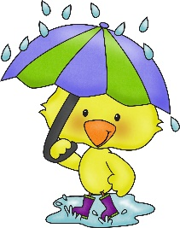
Janet Viola
Director/Manager

This Photo by Unknown Author is licensed under CC BY-NC

